Chapter 11, Problem 76.

Obtain the wattmeter reading of the circuit in Fig. 11.91 below.

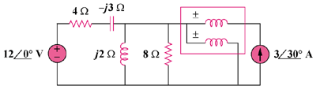

Figure 11.91
For Prob. 11.76.

